MODULE END ASSIGNMENT
ANALYZING E-LEARNING PLATFORM PURCHASES USING MYSQL
Task
1.Database Setup & Data Entry
- Create a new database.
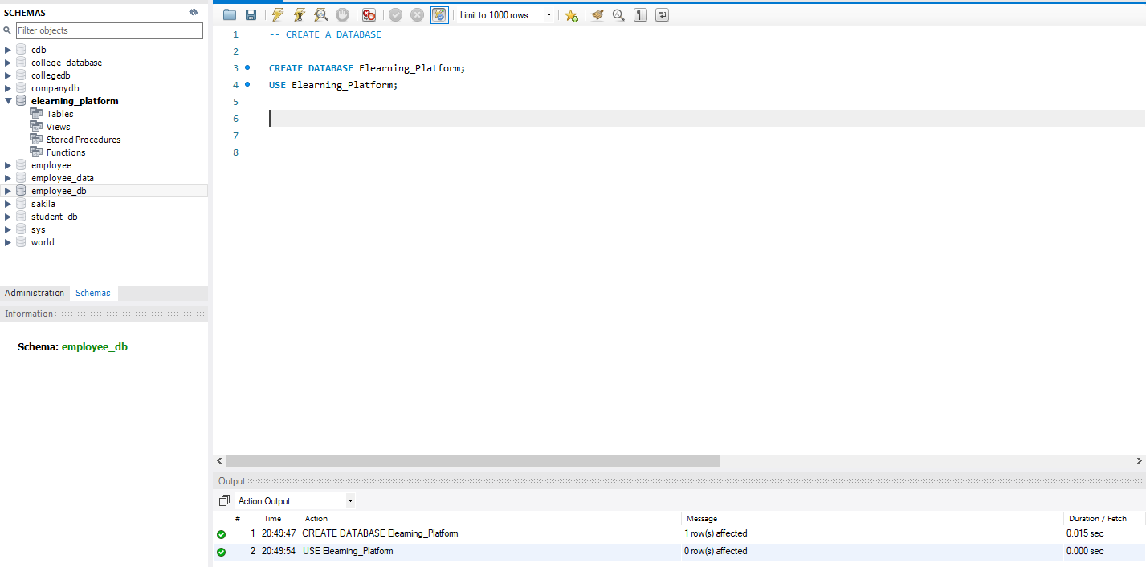
- Create the three tables with proper:
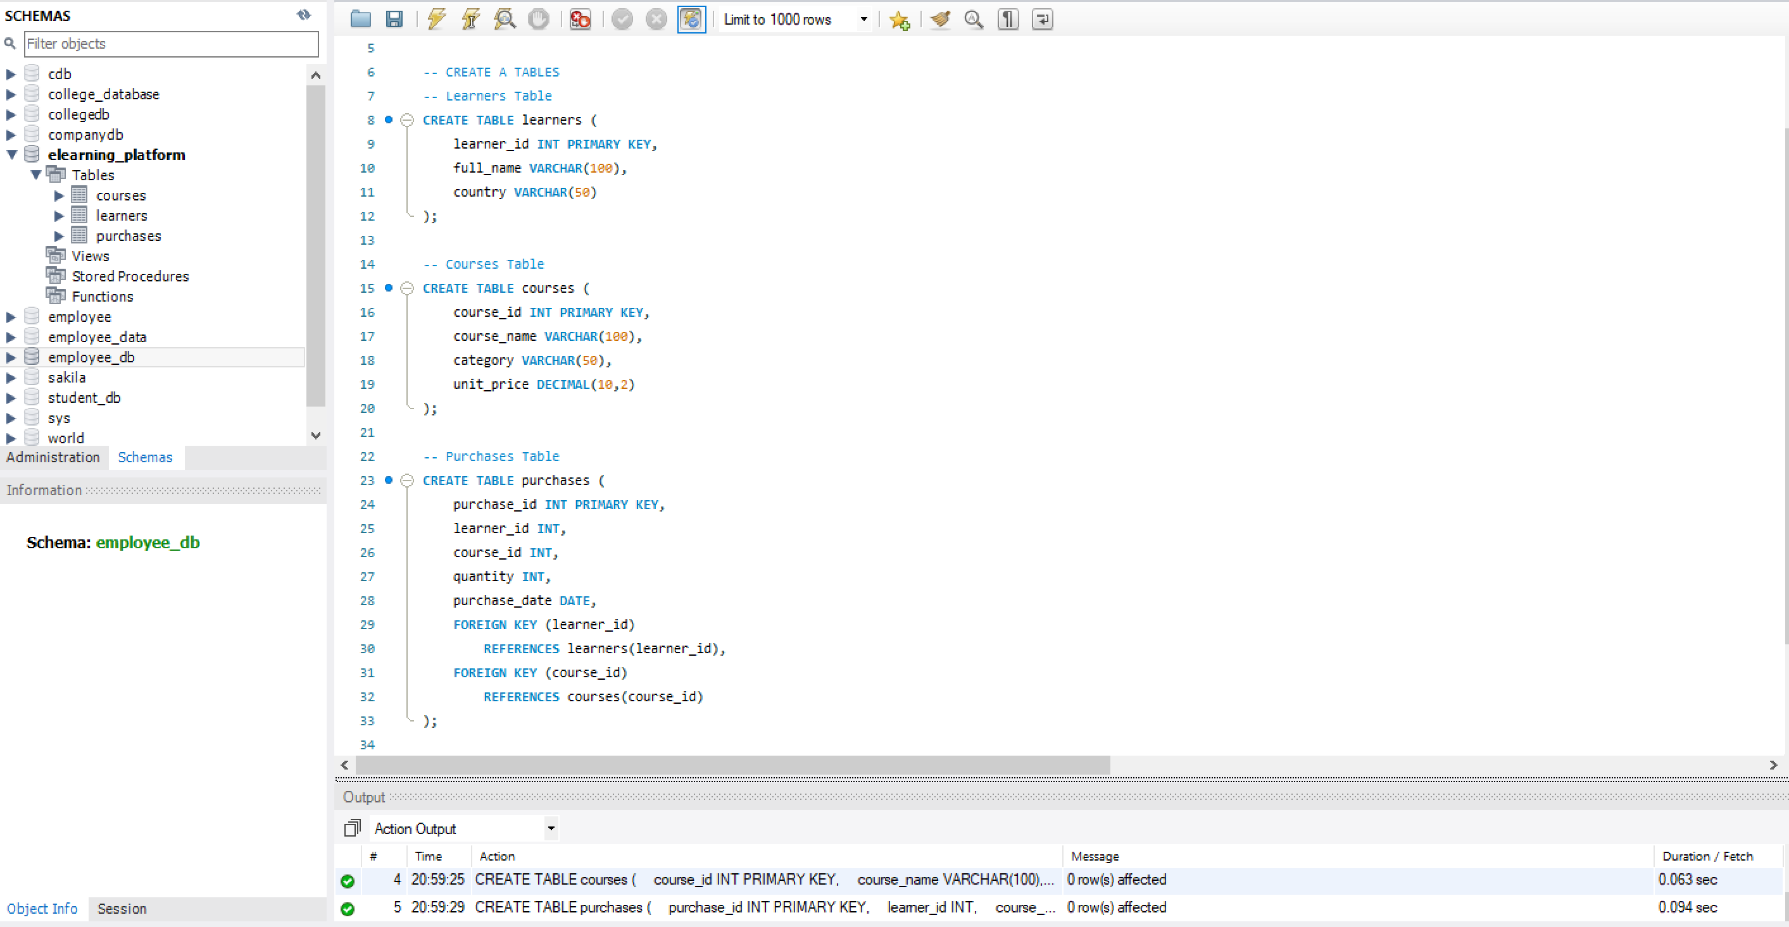
- Insert sample data:
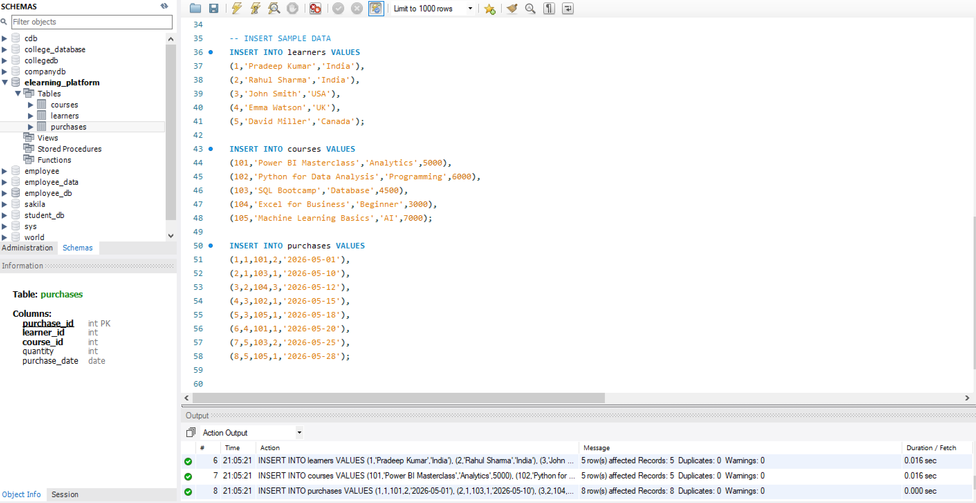
2. Data Exploration Using Joins
- INNER JOIN
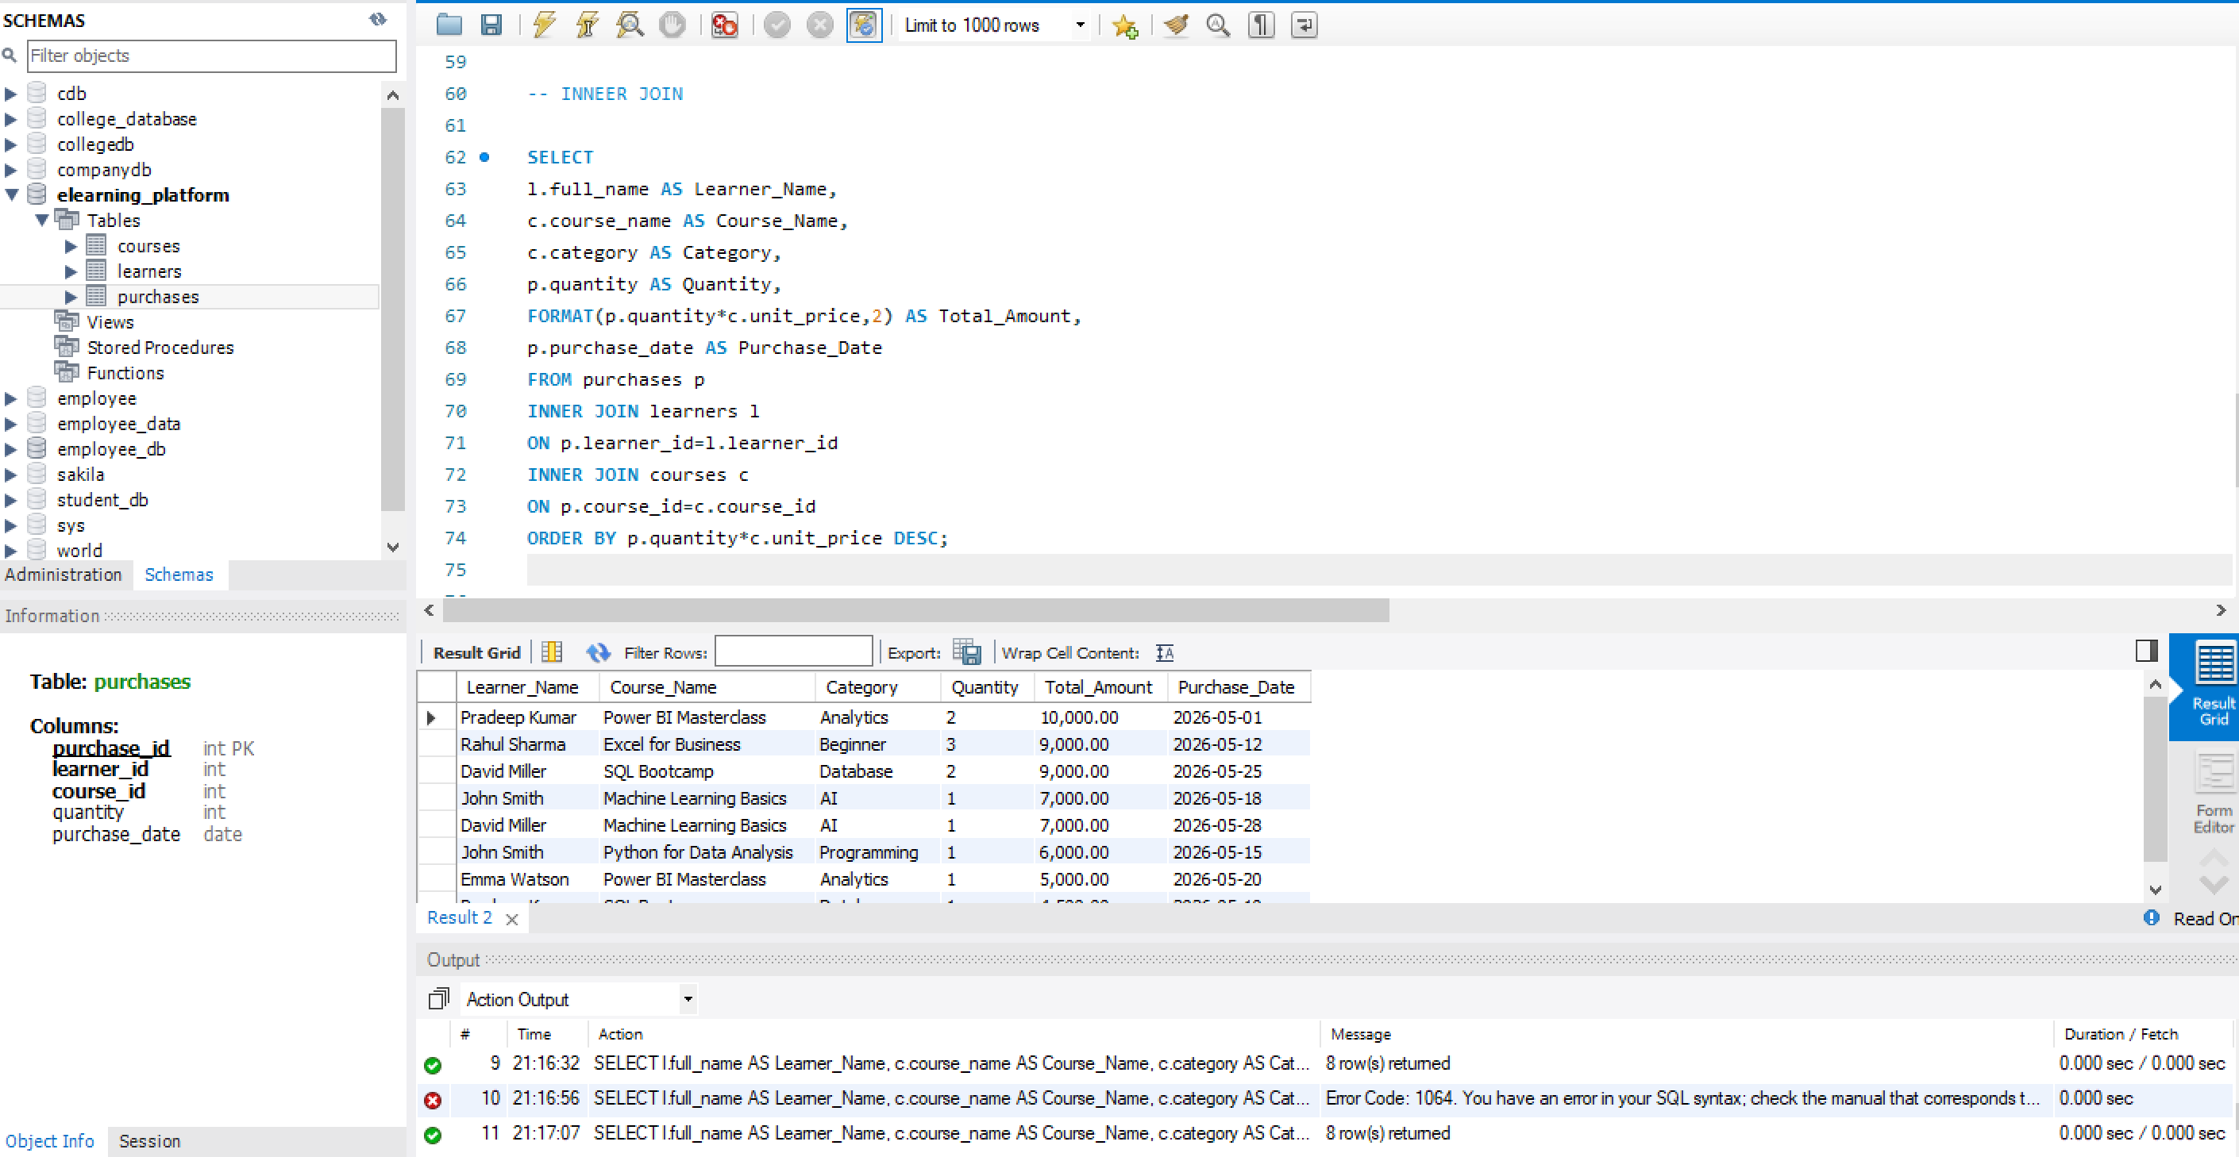
- LEFT JOIN
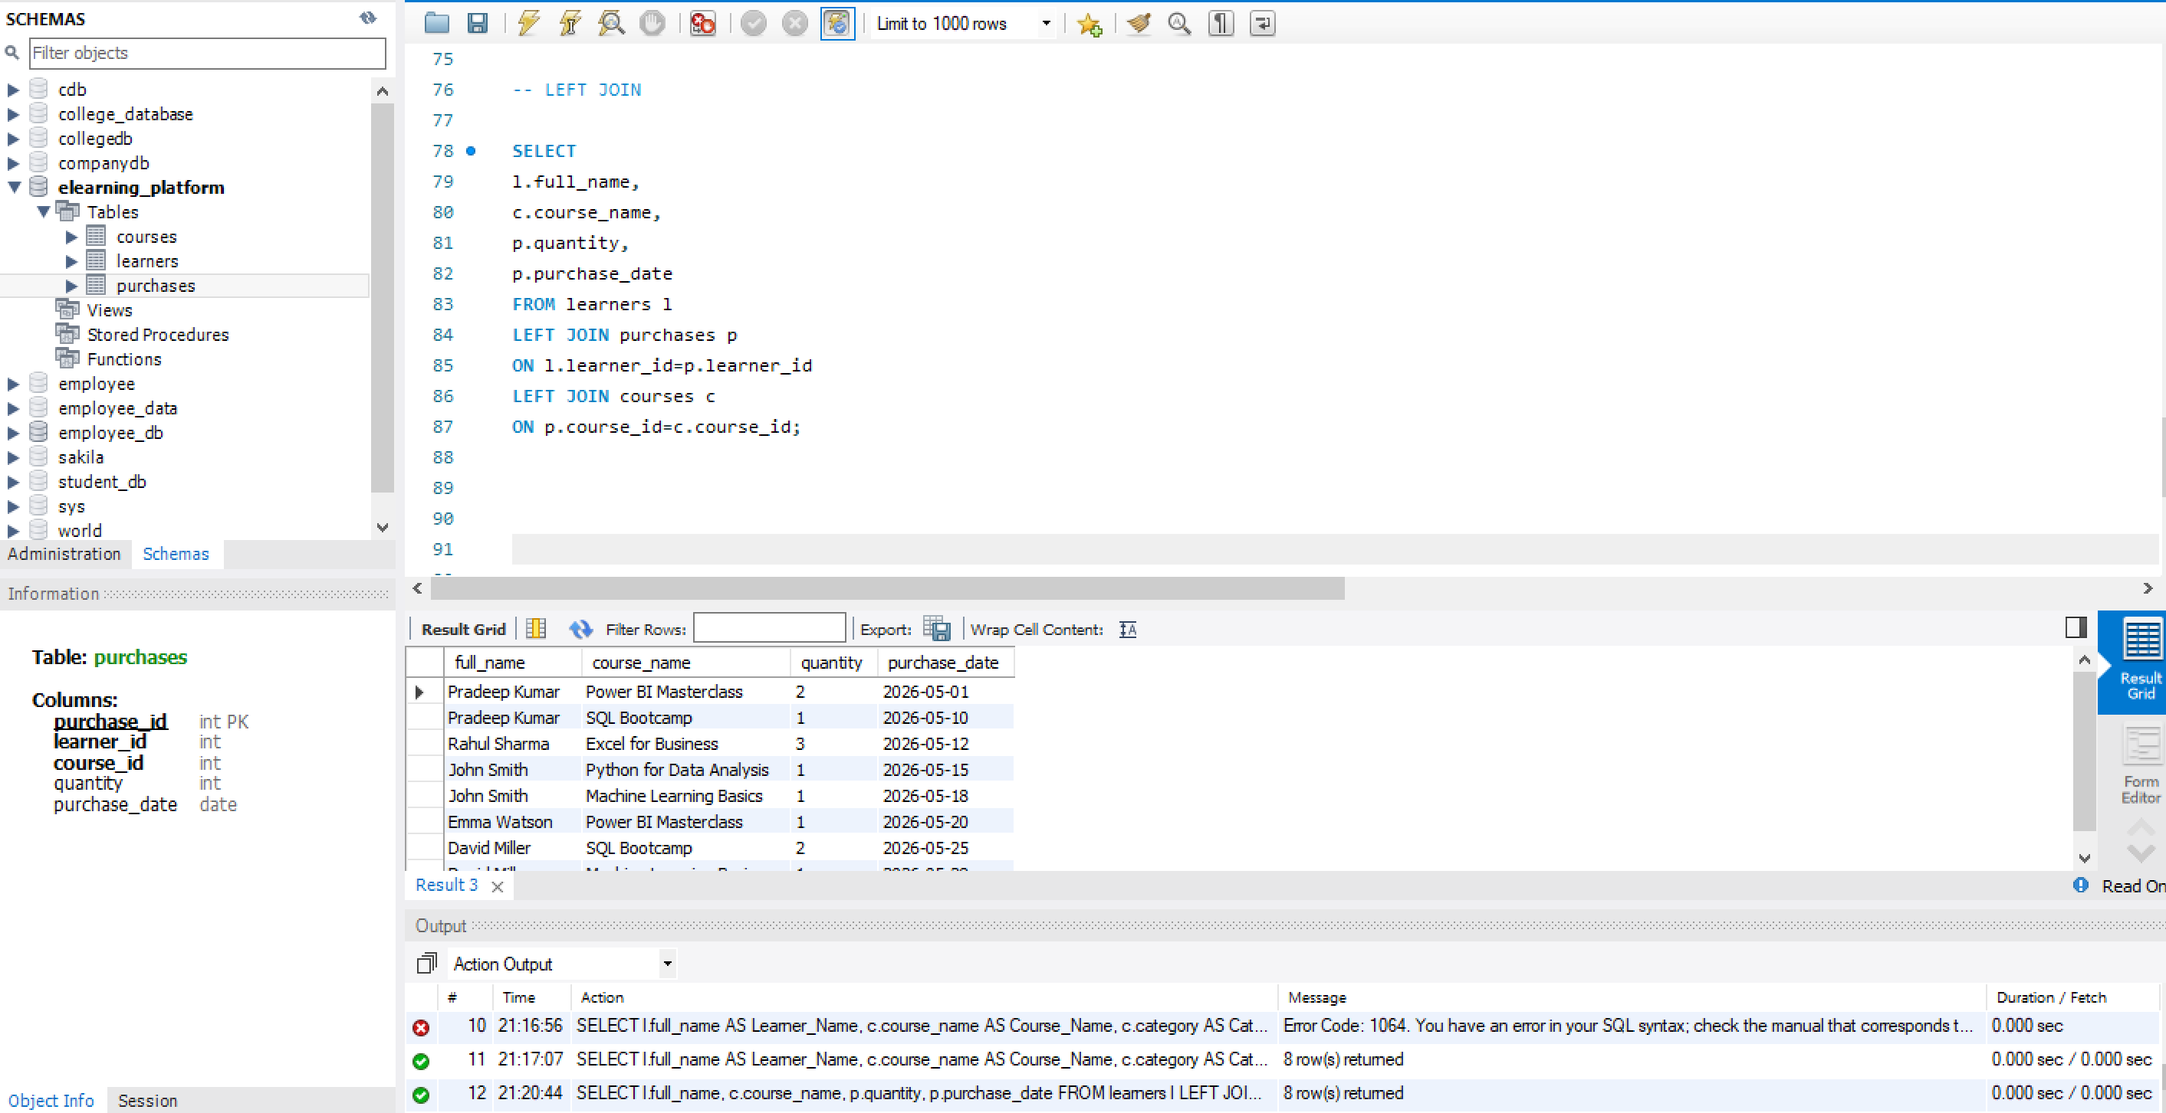
- RIGHT JOIN
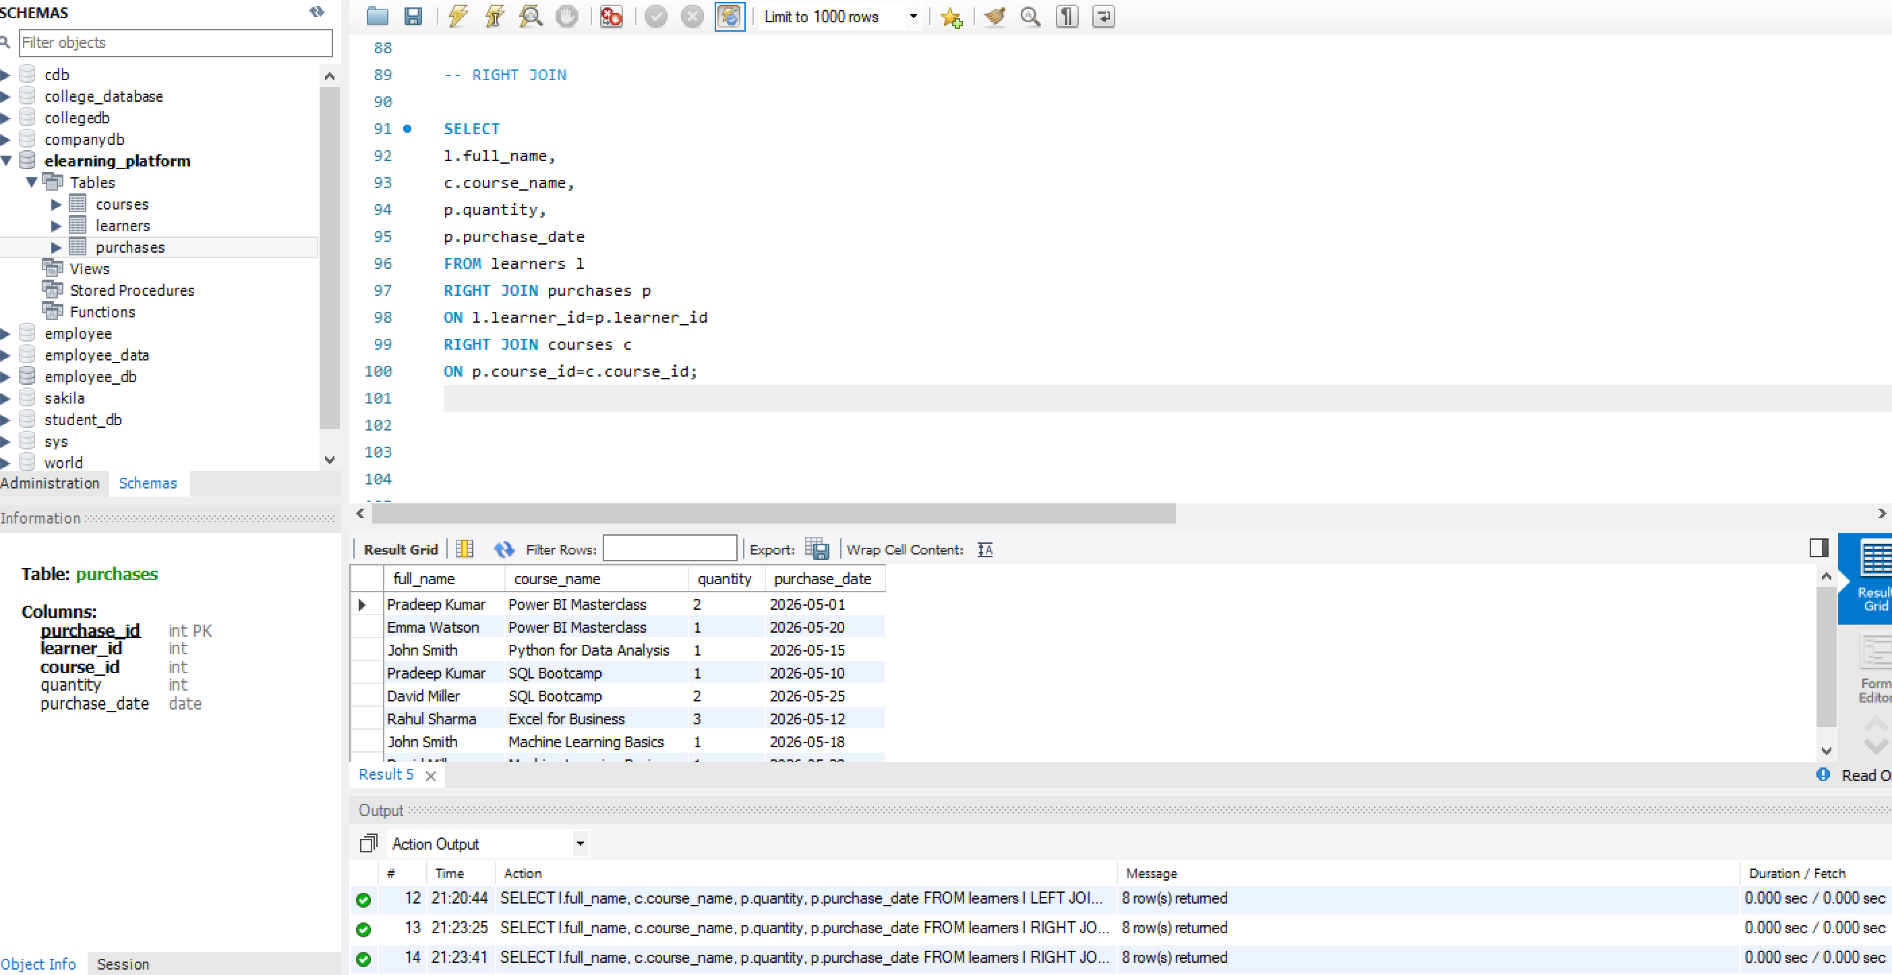

3. Core Analytical Queries (Q1–Q5)
Q1. Display each learner’s total spending with their country.
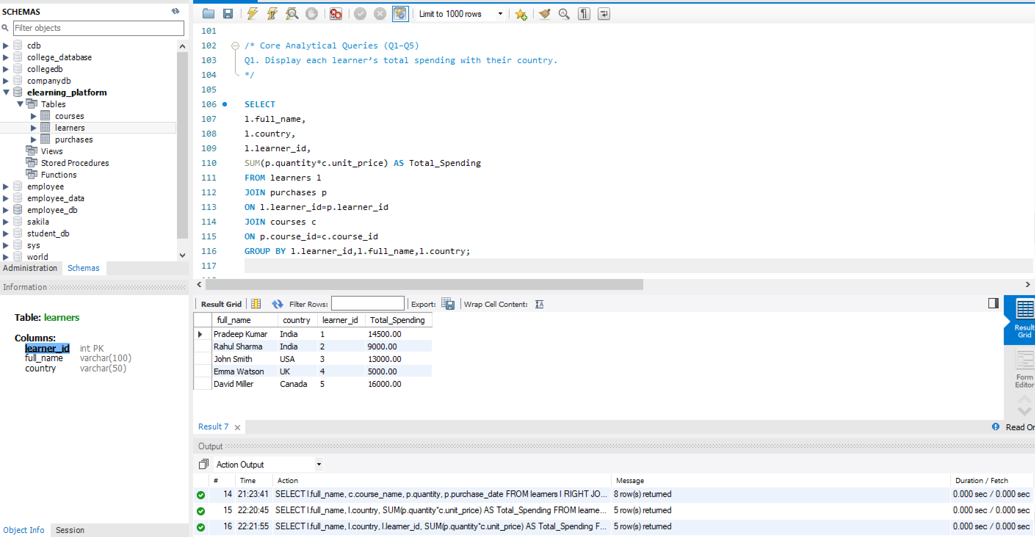
Q2. Find the top 3 most purchased courses by quantity.
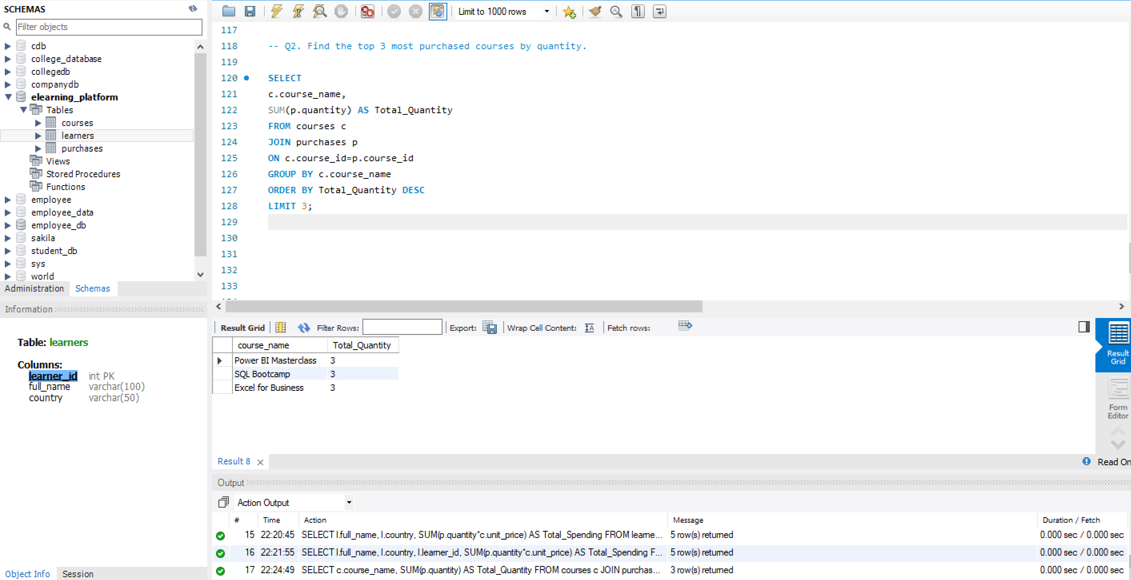
Q3. Show each category’s:
- Total revenue
- Number of unique learners
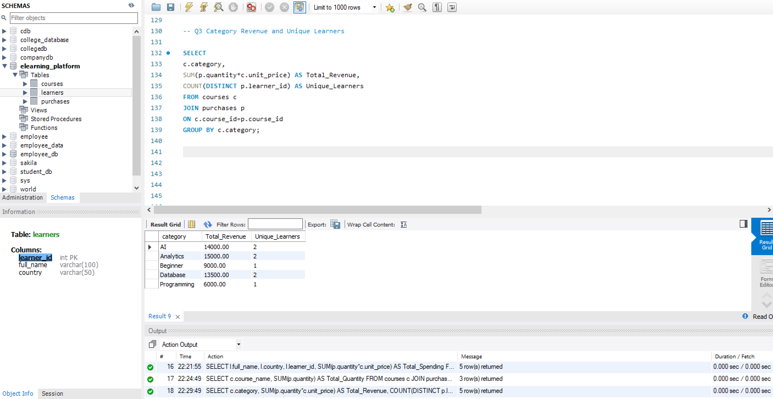
Q4. List learners who purchased from more than one category.
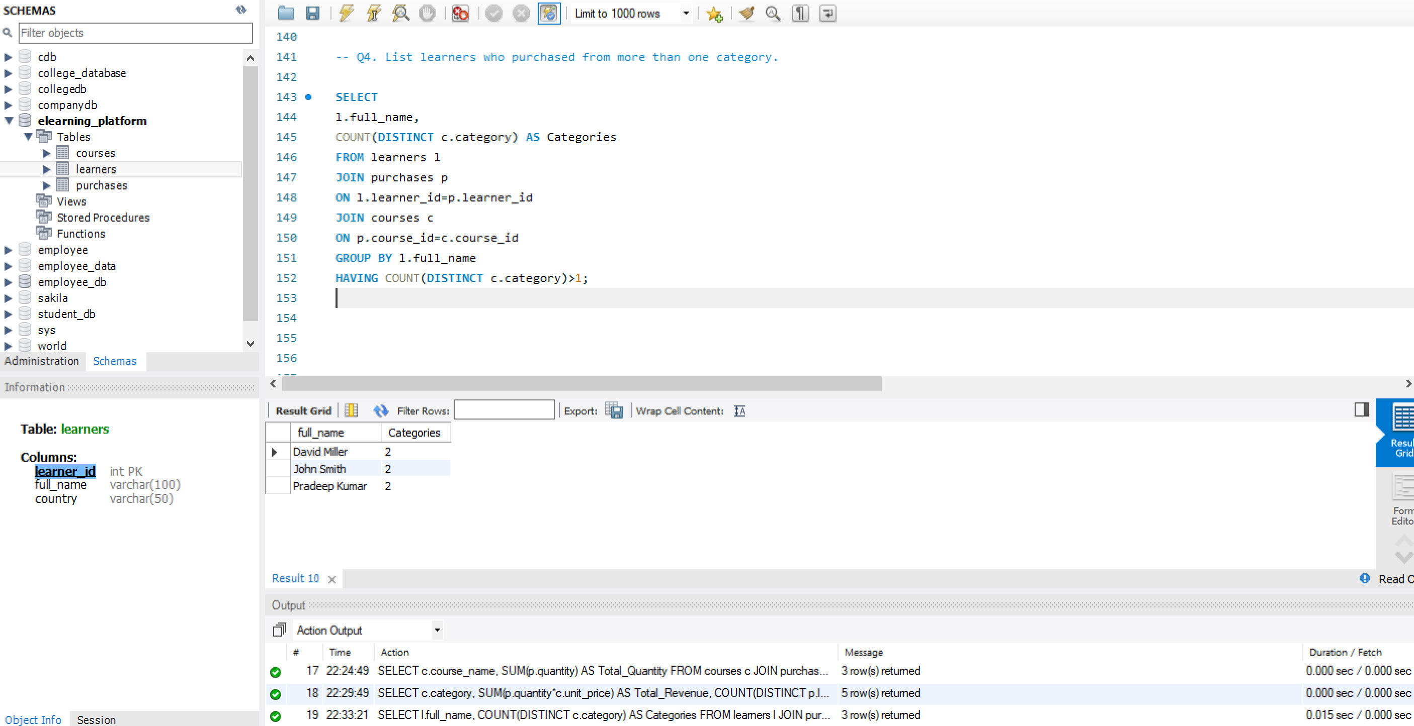
Q5. Identify courses never purchased.
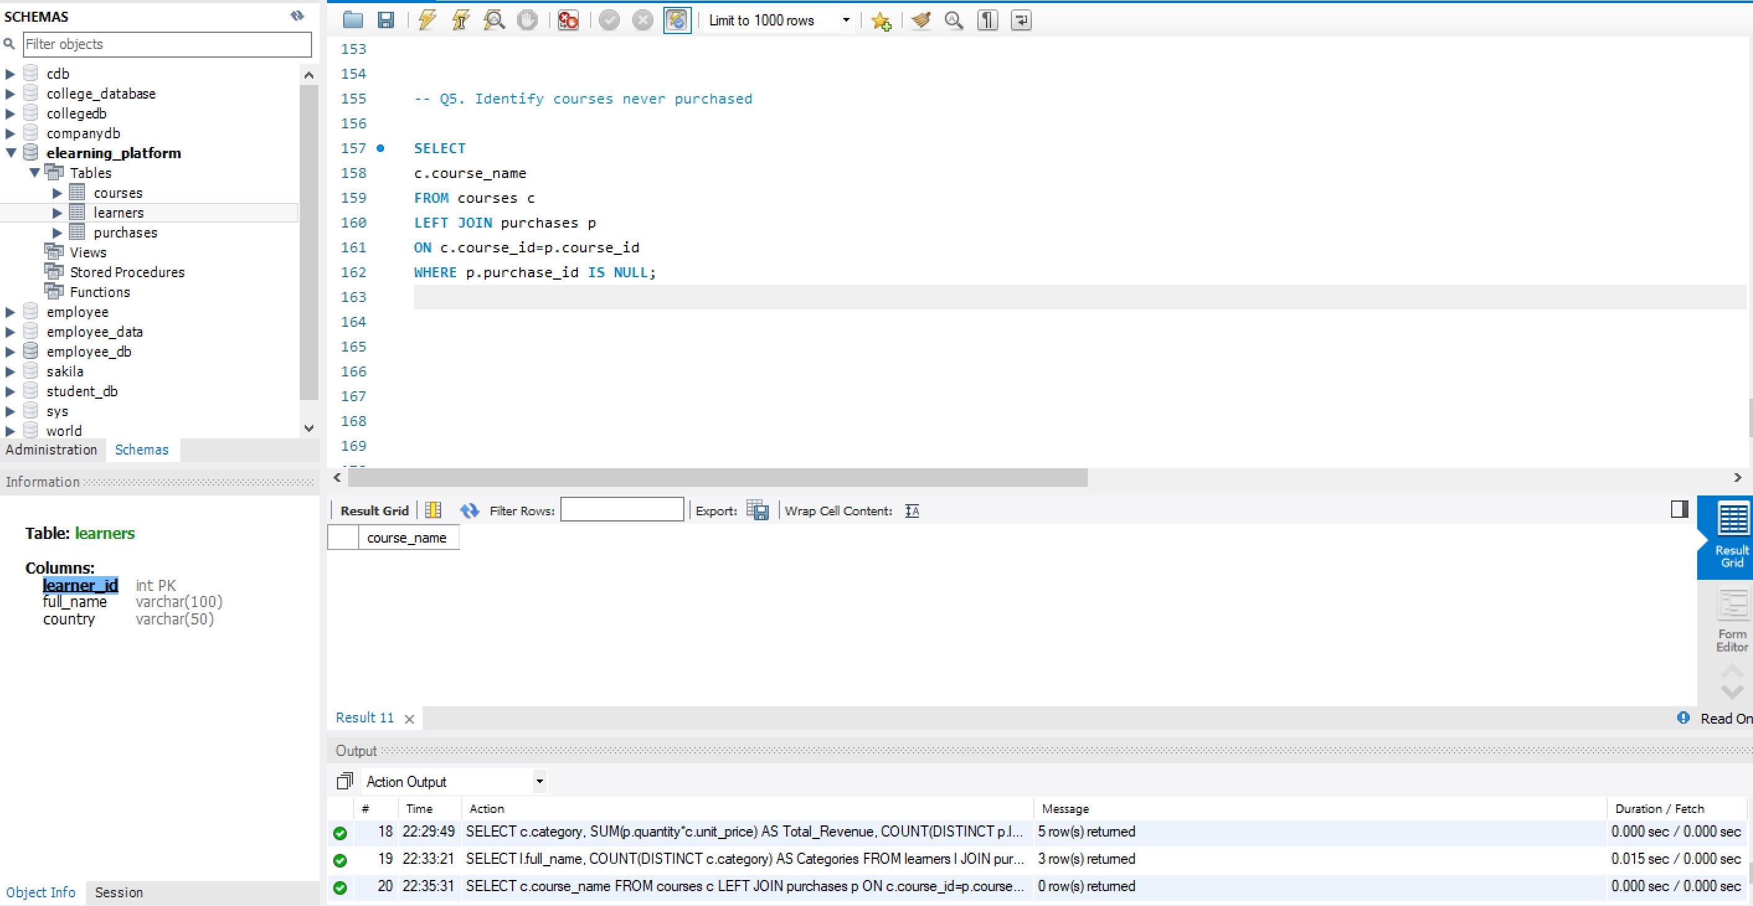
4. Subqueries & Correlated Subqueries
Q6. Find learners whose total spending is above the average learner spending.
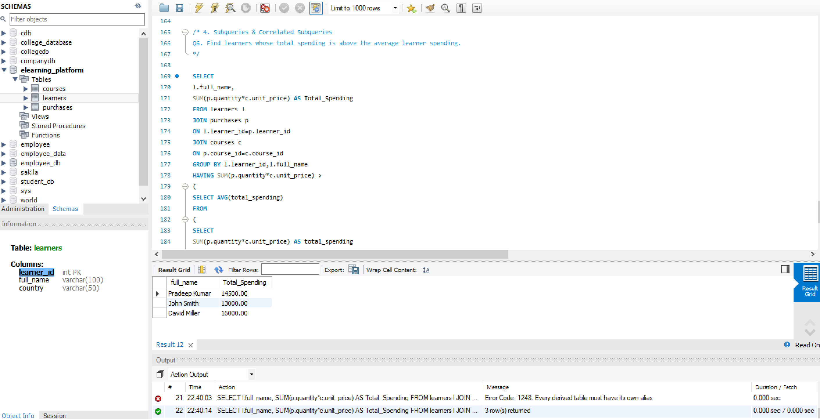
Q7. Display courses whose price is higher than any course in the ‘Beginner’ category.
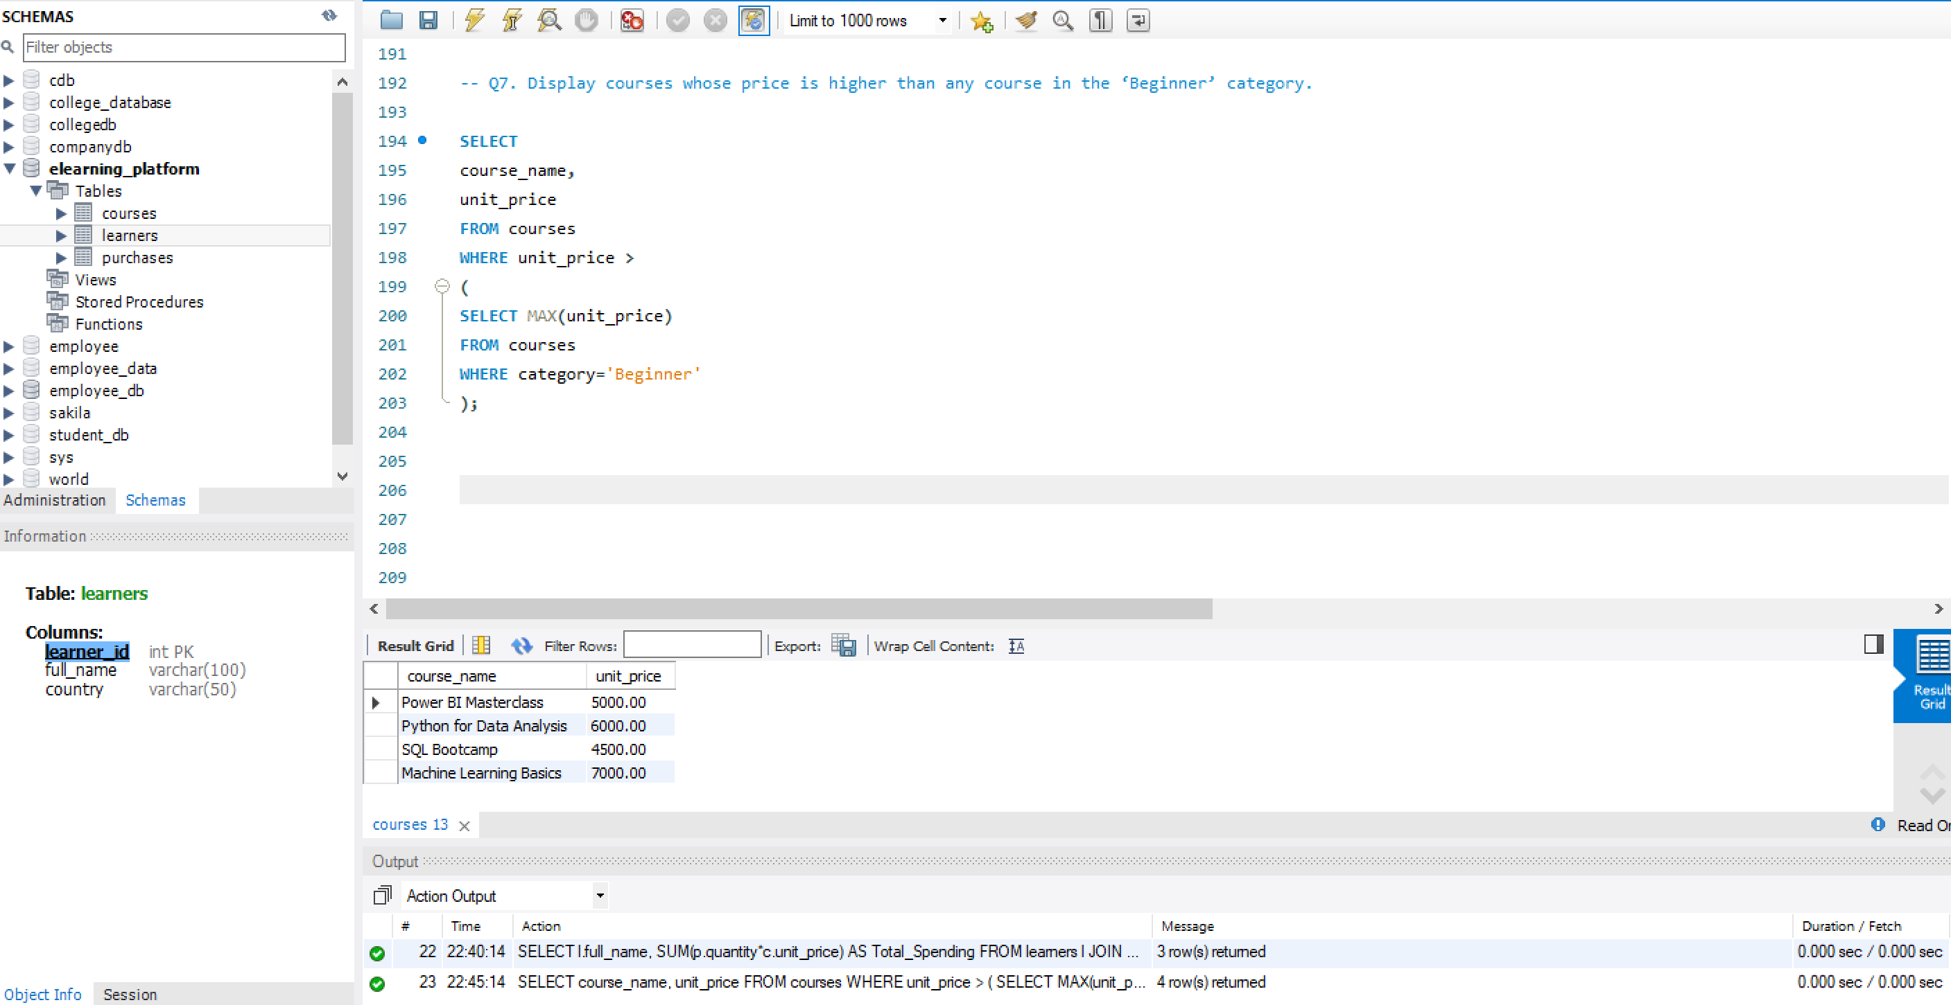
Q8. Find learners who spent more than the average spending in their country.
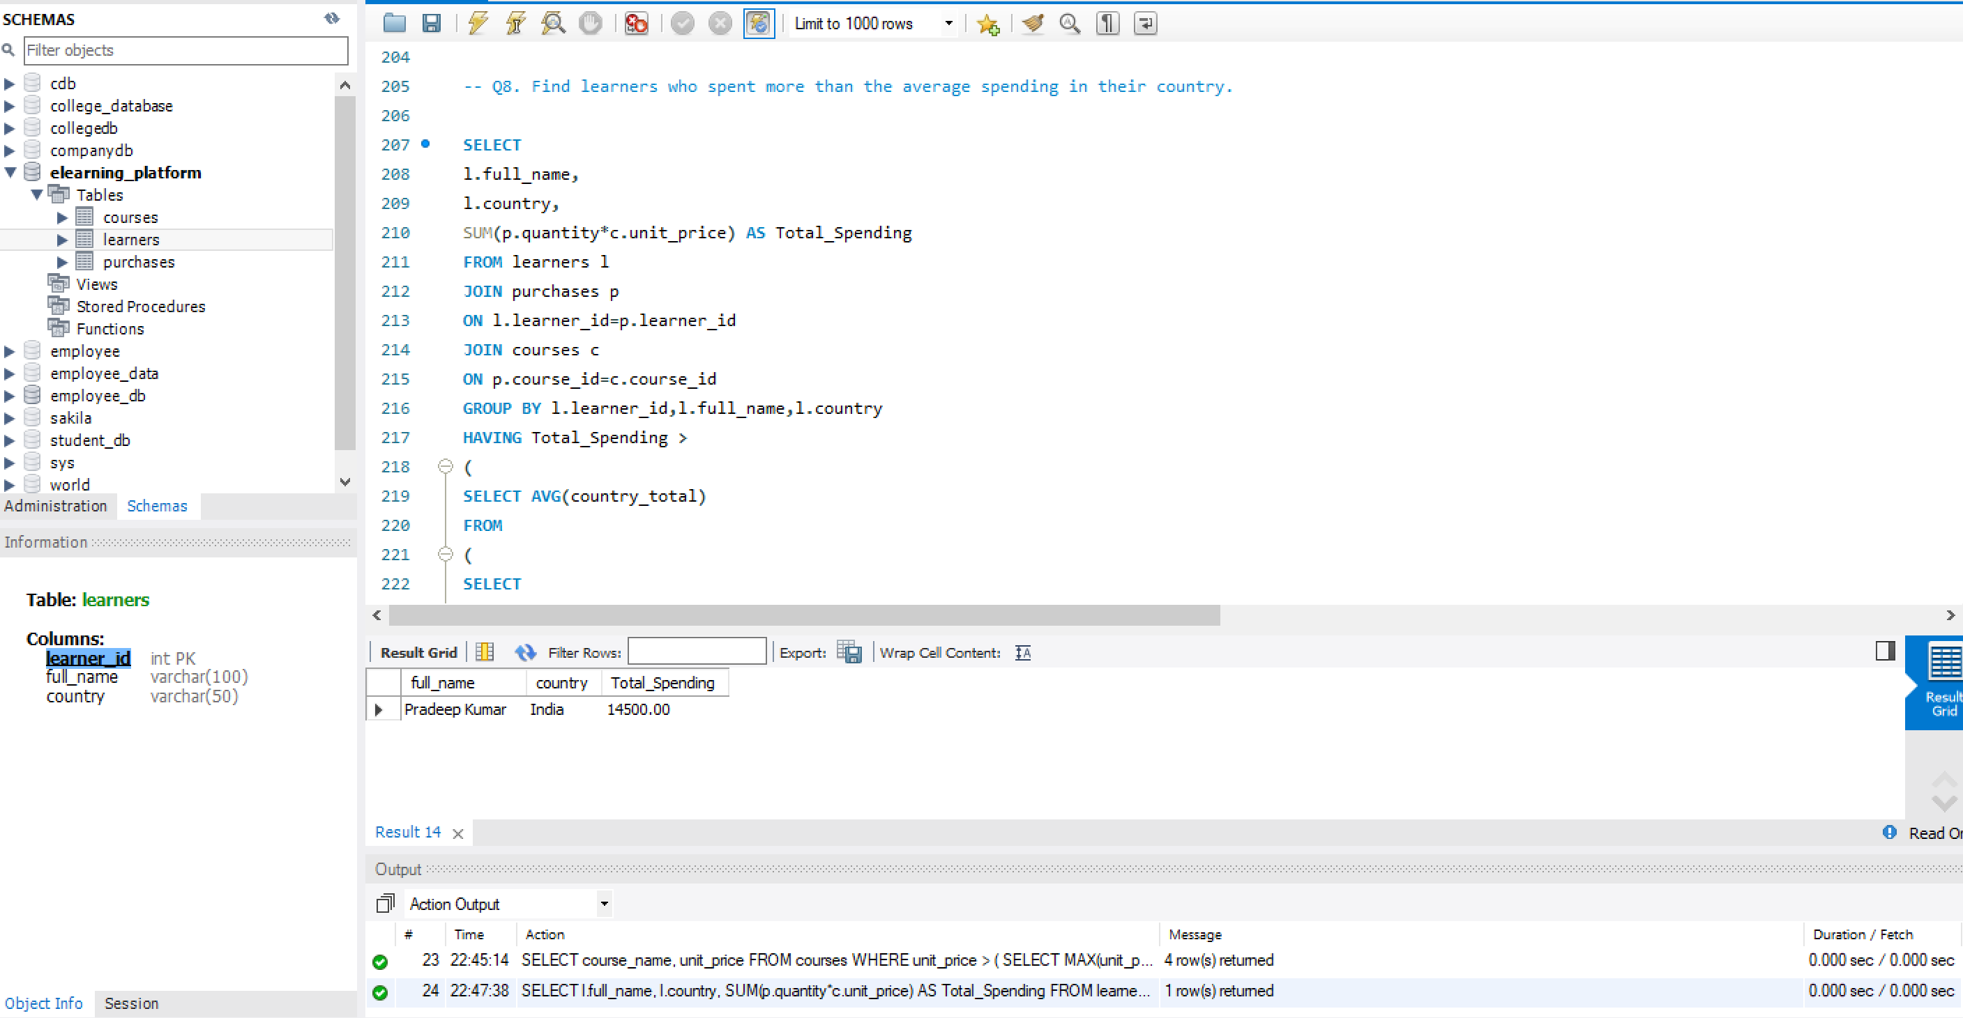
5. CTE, CASE, View, and NULL Handling
Q9. Use a CTE to calculate total spending per learner, then:
Display learners with spending above 10,000.
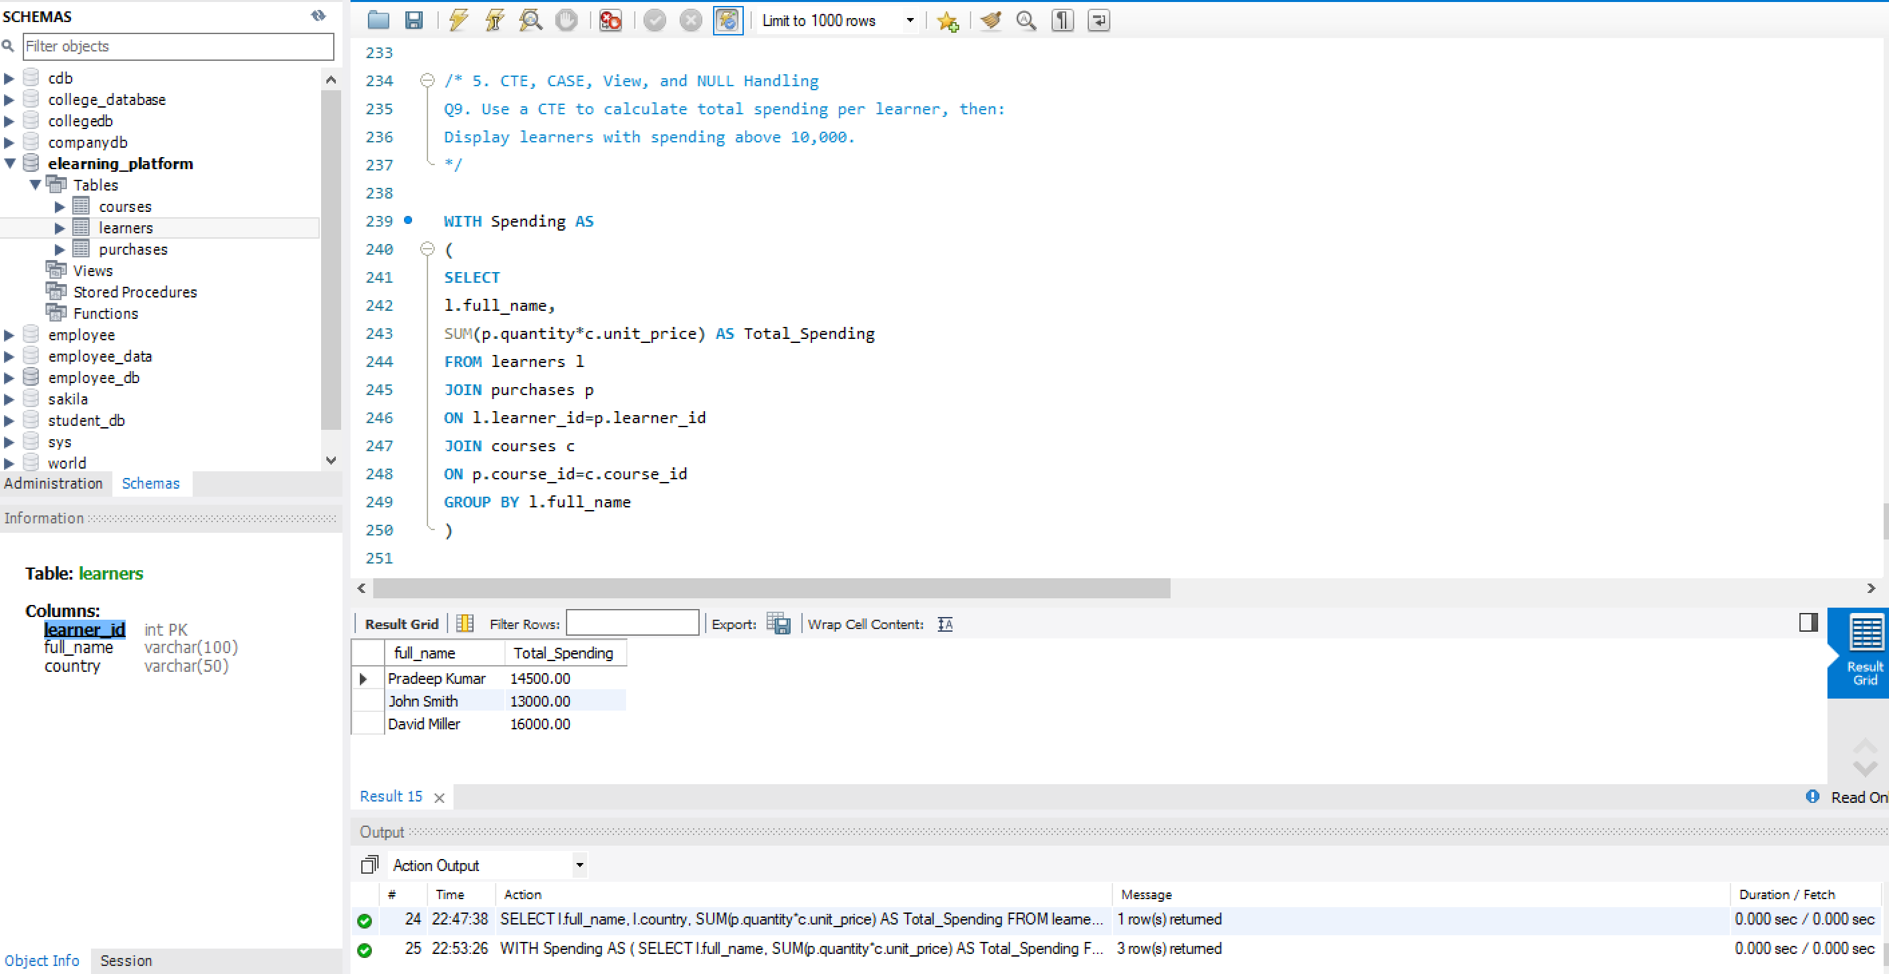
Q10. CASE Expression Classify learners based on spending:
- Above 15,000 → “High Value”,
- 8,000–15,000 → “Medium Value”,
- Below 8,000 → “Low Value”.
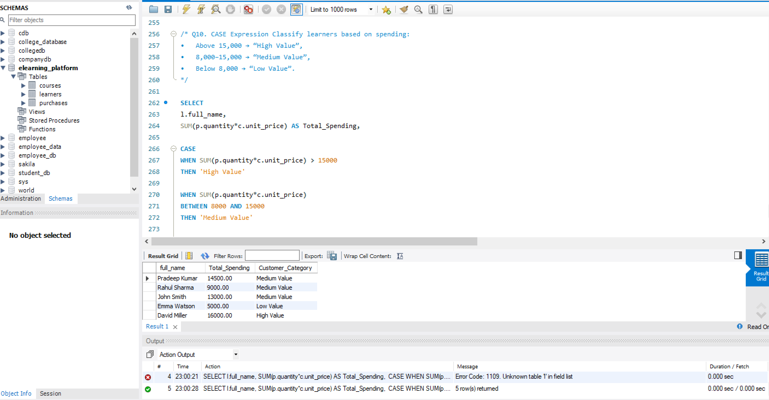
Q11. NULL Handling
- Display all courses and replace NULL purchase counts with 0 using: IFNULL() or COALESCE()
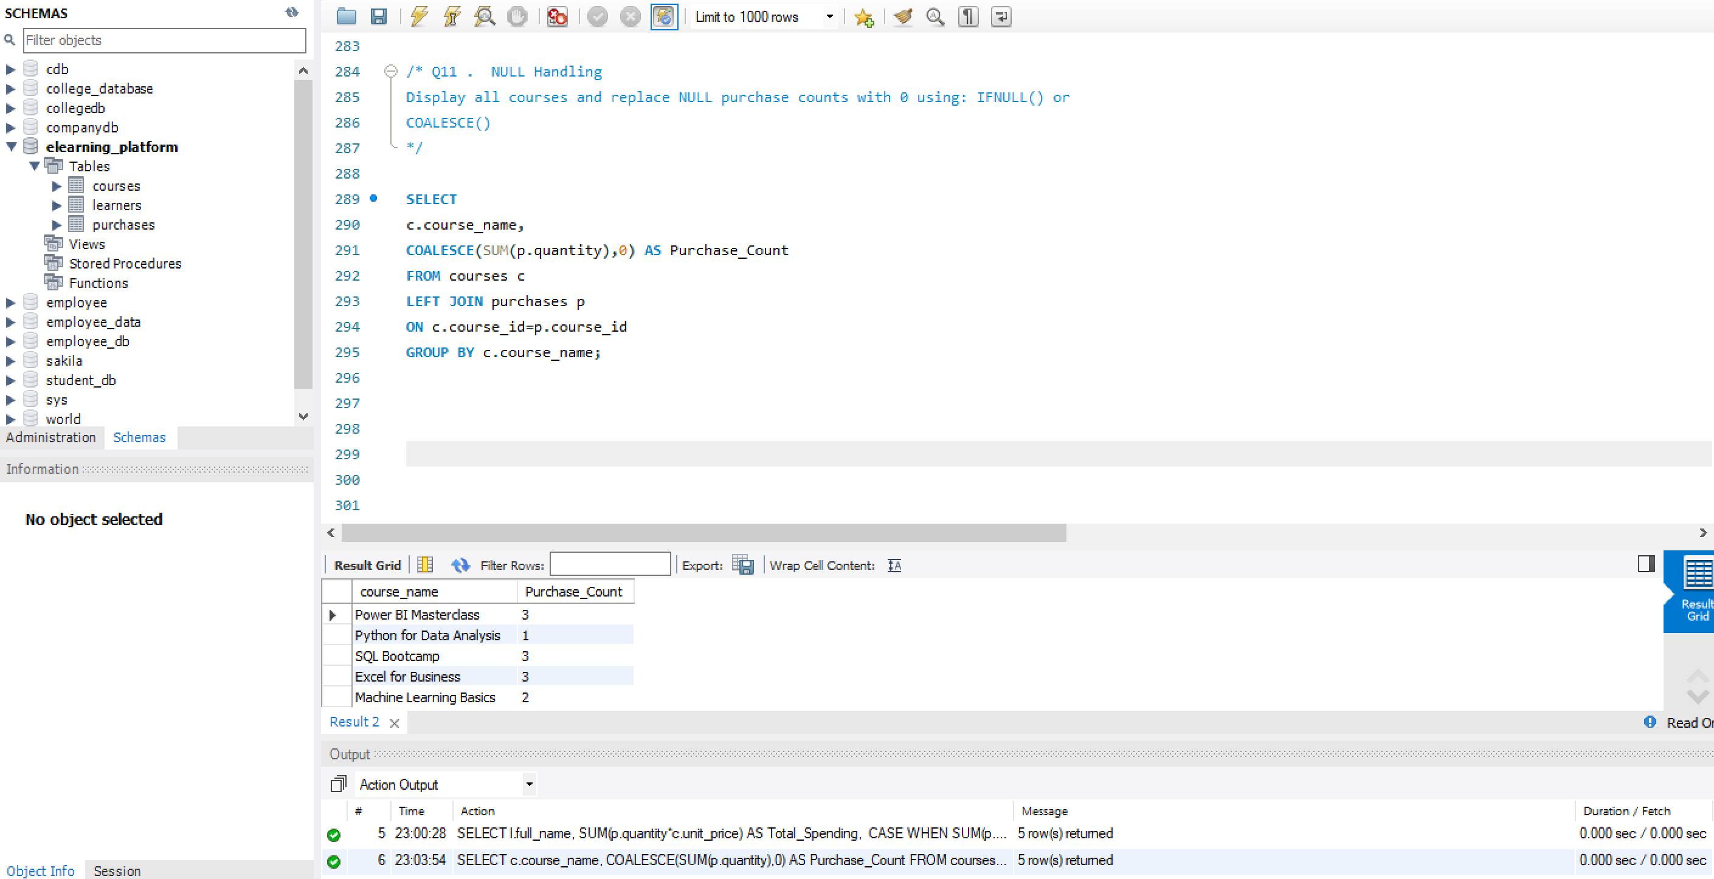

Q12. View
- Create a view: category_performance_view
- Showing:
- Category
- Total revenue
- Number of purchases
- Average revenue per purchase
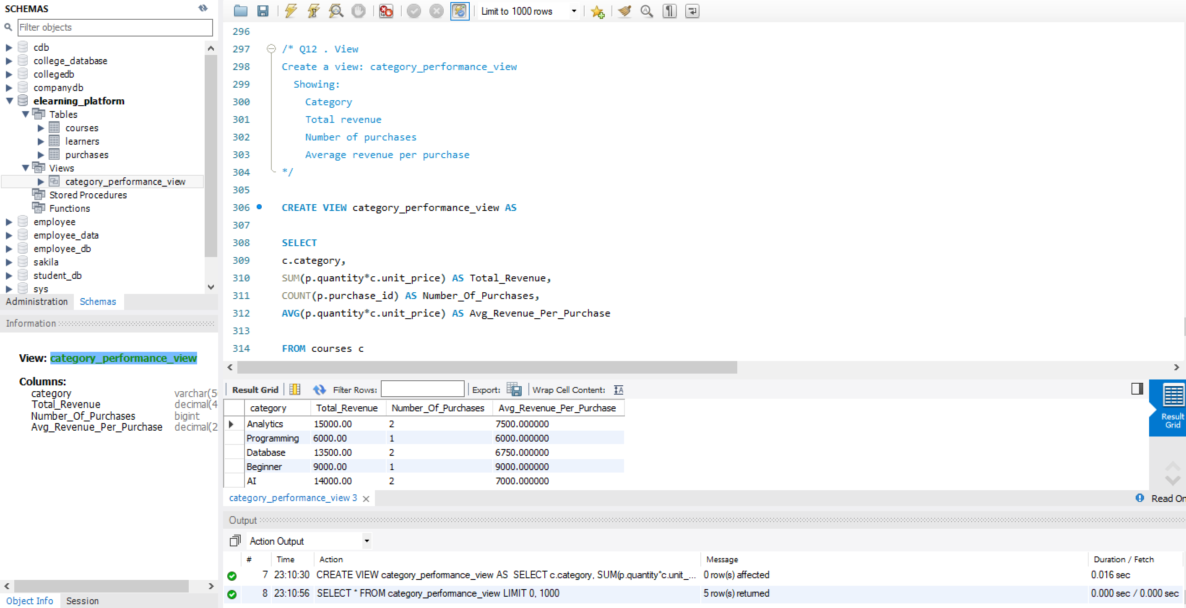

ANALYZING E-LEARNING PLATFORM PURCHASES USING MYSQL
PROJECT SUMMARY REPORT
- Project Overview
This project focuses on analyzing purchase data from an E-Learning Platform using MySQL to gain meaningful insights into learner behavior, course performance, and revenue generation. The database consists of three relational tables: Learners, Courses, and Purchases. Various SQL concepts such as Joins, Aggregate Functions, Subqueries, Common Table Expressions (CTEs), CASE Statements, Views, and NULL Handling functions were applied to analyze transactional data and convert it into valuable business information. The objective of this project is to support data-driven decision-making and identify opportunities for improving course performance and customer engagement.
- Key Insights from the Analysis
- Certain course categories generated higher revenue than others, indicating strong learner demand and greater market interest.
- The top three most purchased courses contributed significantly to total enrollments and represented the platform's best-performing courses.
- A small group of learners accounted for a major portion of total spending, identifying them as high-value customers.
- Several learners purchased courses from multiple categories, demonstrating cross-category engagement and increased spending behavior.
- Some courses had little or no purchase activity, indicating the need for improved marketing strategies and better course visibility.
- Category-wise revenue and unique learner analysis helped identify the most profitable and popular course segments.
- Learners who spent above their country's average spending level were identified as premium customers with higher purchasing potential.

- Recommendations
- Focus marketing efforts on top-performing course categories to maximize revenue and increase learner acquisition.
- Introduce personalized recommendations and targeted campaigns for high-value learners to improve customer retention.
- Develop bundle offers and cross-selling strategies to encourage learners to purchase courses from multiple categories.
- Increase promotional activities and provide discounts for low-performing courses to improve enrollment and visibility.
- Continuously monitor learner behavior and course performance through SQL reports and dashboards to support strategic business decisions.

- Conclusion
This project successfully analyzed e-learning platform purchase data using MySQL and generated meaningful business insights from transactional data. Various SQL concepts, including Joins, Aggregate Functions, Subqueries, CTEs, CASE Statements, Views, and NULL Handling functions, were applied to perform comprehensive data analysis. The analysis identified top-performing course categories, high-value learners, and courses with low purchase activity. It also provided insights into learner purchasing behavior and revenue generation patterns. The findings can help the organization improve marketing strategies, increase customer engagement, and optimize course offerings. This project demonstrated the importance of relational databases and SQL in solving real-world business problems. Overall, the project enhanced practical SQL skills and showcased the ability to transform raw data into actionable insights that support data-driven decision-making and business growth.

